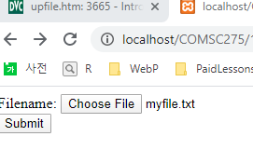

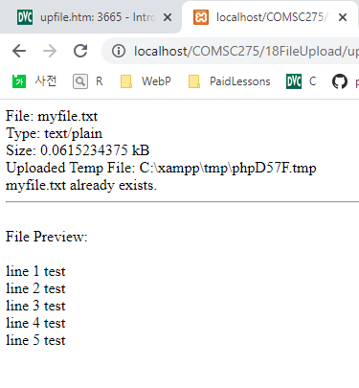

upfile.html

<form action=*"upfile.php"* method=*"post"*

enctype=*"multipart/form-data"*>

<label for=*"file"*>Filename:</label>

<input type=*"file"* name=*"myfile"* id=*"file"* /><br>

<input type=*"submit"* name=*"submit"* value=*"Submit"* />

</form>

upfile.php

<?php

//Check for any server errors in uploading

**if** (**$_FILES**["myfile"]["error"] > 0){

**print** "Error in uploading: {**$_FILES**["myfile"]["error"]}<br>";

**exit**(0);

}

**else** {

**print** "File: " . **$_FILES**["myfile"]["name"] . "<br>";

**print** "Type: " . **$_FILES**["myfile"]["type"] . "<br>";

**print** "Size: " . (**$_FILES**["myfile"]["size"] / 1024) . " kB<br>";

**print** "Uploaded Temp File: " . **$_FILES**["myfile"]["tmp_name"];

**if** (*file_exists*("upload/" . **$_FILES**["myfile"]["name"])){

**print** "<br>" . **$_FILES**["myfile"]["name"] . " already exists. ";

}

**else** {

*move_uploaded_file*(**$_FILES**["myfile"]["tmp_name"],

"upload/" . **$_FILES**["myfile"]["name"]);

**print** "<br>Stored in: " . "upload/" . **$_FILES**["myfile"]["name"];

}

//for uploading images, see w3

//Previewing .html or .txt files

//copy the

//remove any tags contained in the file for security

$destfile="upload/" . **$_FILES**["myfile"]["name"];

$contents = *file_get_contents*($destfile);

*strip_tags*($contents);

//$contents = htmlentities($contents);

//$contents = htmlspecialchars($contents);

//$contents = htmlspecialchars_decode($contents);

//store it locally for display

*file_put_contents*(**$_FILES**['myfile']['name'], $contents);

//display contents with newlines converted to breaks

$contents_nl2br=*nl2br*($contents);

**print** <<< Here

<hr />

<br>File Preview:<br /><br>

$contents_nl2br

Here;

}